**ROAD ACCIDENT REPORT SQL QUERIES**

**Current Year Casualties**

select SUM(number_of_casualties) as CY_Casualties from road_accident

where YEAR(accident_date) = '2022'

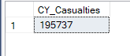

**Previous Year Casualties**

select SUM(number_of_casualties) as PY_Casualties from road_accident

where YEAR(accident_date) = '2021'



**Current Year Accident**

select count(distinct accident_index) as CY_Accidents from road_accident

where year(accident_date) = '2022'



**Previous Year Accident**

select count(distinct accident_index) as PY_Accidents from road_accident

where year(accident_date) = '2021'

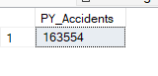

**Current Year Accident By Road Surface Conditions**

select SUM(number_of_casualties) As CY_Casualties

from road_accident

where YEAR(accident_date)='2022' and road_surface_conditions = 'Dry'



select SUM(number_of_casualties) As CY_Casualties

from road_accident

where YEAR(accident_date)='2022' and road_surface_conditions = 'Wet or damp'

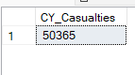

select SUM(number_of_casualties) As CY_Casualties

from road_accident

where YEAR(accident_date)='2022' and road_surface_conditions = 'Frost or ice'



**Previous Year Accident By Road Surface Conditions**

select SUM(number_of_casualties) As PY_Casualties

from road_accident

where YEAR(accident_date)='2021' and road_surface_conditions = 'Dry'

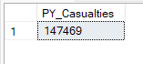

select SUM(number_of_casualties) As PY_Casualties

from road_accident

where YEAR(accident_date)='2021' and road_surface_conditions = 'Wet or damp'

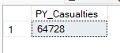

select SUM(number_of_casualties) As PY_Casualties

from road_accident

where YEAR(accident_date)='2021' and road_surface_conditions = 'Frost or ice'



**Current Year Slight Casualties**

select sum(number_of_casualties) as CY_Slight_Casualties from road_accident

where accident_severity = 'Slight' And year(accident_date) = '2022'



**Current Year Fatal Casualties**

select sum(number_of_casualties) as CY_Fatal_Casualties from road_accident

where accident_severity = 'Fatal' And year(accident_date) = '2022'



**Current Year Serious Casualties**

select sum(number_of_casualties) as CY_Serious_Casualties from road_accident

where accident_severity = 'Serious' And year(accident_date) = '2022'

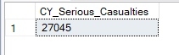

**Previous Year Slight Casualties**

select sum(number_of_casualties) as PY_Slight_Casualties from road_accident

where accident_severity = 'Slight' And year(accident_date) = '2021'



**Previous Year Fatal Casualties**

select sum(number_of_casualties) as PY_Fatal_Casualties from road_accident

where accident_severity = 'Fatal' And year(accident_date) = '2021'

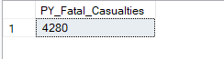

**Previous Year Serious Casualties**

select sum(number_of_casualties) as PY_Serious_Casualties from road_accident

where accident_severity = 'Serious' And year(accident_date) = '2021'



**Current Year Slight Casualties In Percentage**

select CAST(Sum(number_of_casualties) as decimal(10,2))*100/

(select CAST(sum(number_of_casualties) as decimal(10,2)) from road_accident )as PCT

from road_accident

where accident_severity = 'slight' And year(accident_date) = '2022'

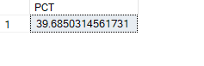

**Current Year Serious Casualties In Percentage**

select CAST(Sum(number_of_casualties) as decimal(10,2))*100/

(select CAST(sum(number_of_casualties) as decimal(10,2)) from road_accident )as PCT

from road_accident

where accident_severity = 'Serious' And year(accident_date) = '2022'

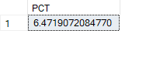

**Current Year Fatal Casualties In Percentage**

select CAST(Sum(number_of_casualties) as decimal(10,2))*100/

(select CAST(sum(number_of_casualties) as decimal(10,2)) from road_accident )as PCT

from road_accident

where accident_severity = 'Fatal' And year(accident_date) = '2022'



**Previous Year Slight Casualties In Percentage**

select CAST(Sum(number_of_casualties) as decimal(10,2))*100/

(select CAST(sum(number_of_casualties) as decimal(10,2)) from road_accident )as PCT

from road_accident

where accident_severity = 'slight' And year(accident_date) = '2021'

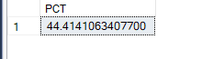

**Previous Year Serious Casualties In Percentage**

select CAST(Sum(number_of_casualties) as decimal(10,2))*100/

(select CAST(sum(number_of_casualties) as decimal(10,2)) from road_accident )as PCT

from road_accident

where accident_severity = 'Serious' And year(accident_date) = '2021'

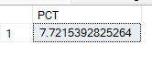

**Previous Year Fatal Casualties In Percentage**

select CAST(Sum(number_of_casualties) as decimal(10,2))*100/

(select CAST(sum(number_of_casualties) as decimal(10,2)) from road_accident )as PCT

from road_accident

where accident_severity = 'Fatal' And year(accident_date) = '2021'



**Current Year Casualties By Vehicle Type**

SELECT

CASE

when Vehicle_Type IN ('Agricultural vehicle') THEN 'Agricutural'

when Vehicle_Type IN ('car','Taxi/Private hire car') THEN 'Cars'

when Vehicle_Type IN ('Motorcycle 125cc and under' , 'Motorcycle 50cc and under' , 'Motorcycle over 125cc and up to 500cc','Motorcycle over 500cc','Pedal cycle') THEN 'Bike'

when Vehicle_Type IN ('Bus or coach (17 or more pass seats)' , 'Minibus (8 - 16 passenger seats)') THEN 'Bus'

when Vehicle_Type IN ('Goods 7.5 tonnes mgw and over' , 'Goods over 3.5t. and under 7.5t','Van/Goods 3.5 tonnes mgw or under') THEN 'Van'

ELSE'Other'

end as vehicle_group,

sum(number_of_casualties) as CY_Casualties

from road_accident

where YEAR(accident_date) = '2022'

group by

CASE

when Vehicle_Type IN ('Agricultural vehicle') THEN 'Agricutural'

when Vehicle_Type IN ('car','Taxi/Private hire car') THEN 'Cars'

when Vehicle_Type IN ('Motorcycle 125cc and under' , 'Motorcycle 50cc and under' , 'Motorcycle over 125cc and up to 500cc','Motorcycle over 500cc','Pedal cycle') THEN 'Bike'

when Vehicle_Type IN ('Bus or coach (17 or more pass seats)' , 'Minibus (8 - 16 passenger seats)') THEN 'Bus'

when Vehicle_Type IN ('Goods 7.5 tonnes mgw and over' , 'Goods over 3.5t. and under 7.5t','Van/Goods 3.5 tonnes mgw or under') THEN 'Van'

ELSE 'Other'

END

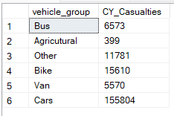

**Previous Year Casualties By Vehicle Type**

SELECT

CASE

when Vehicle_Type IN ('Agricultural vehicle') THEN 'Agricutural'

when Vehicle_Type IN ('car','Taxi/Private hire car') THEN 'Cars'

when Vehicle_Type IN ('Motorcycle 125cc and under' , 'Motorcycle 50cc and under' , 'Motorcycle over 125cc and up to 500cc','Motorcycle over 500cc','Pedal cycle') THEN 'Bike'

when Vehicle_Type IN ('Bus or coach (17 or more pass seats)' , 'Minibus (8 - 16 passenger seats)') THEN 'Bus'

when Vehicle_Type IN ('Goods 7.5 tonnes mgw and over' , 'Goods over 3.5t. and under 7.5t','Van/Goods 3.5 tonnes mgw or under') THEN 'Van'

ELSE'Other'

end as vehicle_group,

sum(number_of_casualties) as PY_Casualties

from road_accident

where YEAR(accident_date) = '2021'

group by

CASE

when Vehicle_Type IN ('Agricultural vehicle') THEN 'Agricutural'

when Vehicle_Type IN ('car','Taxi/Private hire car') THEN 'Cars'

when Vehicle_Type IN ('Motorcycle 125cc and under' , 'Motorcycle 50cc and under' , 'Motorcycle over 125cc and up to 500cc','Motorcycle over 500cc','Pedal cycle') THEN 'Bike'

when Vehicle_Type IN ('Bus or coach (17 or more pass seats)' , 'Minibus (8 - 16 passenger seats)') THEN 'Bus'

when Vehicle_Type IN ('Goods 7.5 tonnes mgw and over' , 'Goods over 3.5t. and under 7.5t','Van/Goods 3.5 tonnes mgw or under') THEN 'Van'

ELSE 'Other'

END

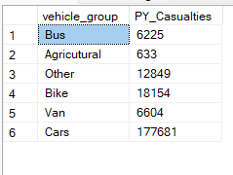

**Current Year Monthly Trend**

select DATENAME(month, accident_date) as Month_Name,sum(number_of_casualties) as CY_Casualties

from road_accident

where year(accident_date)='2022'

group by datename(month,accident_date)

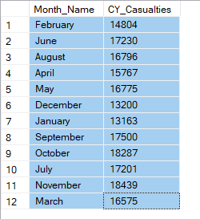

**Previous Year Monthly Trend**

select DATENAME(month, accident_date) as Month_Name,sum(number_of_casualties) as PY_Casualties

from road_accident

where year(accident_date)='2021'

group by datename(month,accident_date)

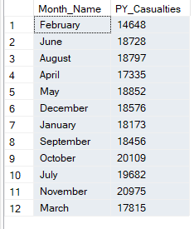

**Casualties By Road Type**

**Previous Year**

select road_type, sum(number_of_casualties) as CY_Casualties from road_accident

where year(accident_date) = '2021'

group by road_type

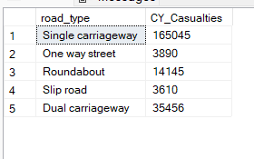

**Current Year**

select road_type, sum(number_of_casualties) as CY_Casualties from road_accident

where year(accident_date) = '2022'

group by road_type

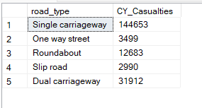

**Casualties By Urban & Rural Area**

**Previous Year**

select urban_or_rural_area , cast (sum(number_of_casualties)as decimal (10,2))*100 /

(select cast (sum(number_of_casualties)as decimal (10,2)) from road_accident where year(accident_date)='2021') as pct

from road_accident

where year(accident_date) = '2021'

group by urban_or_rural_area

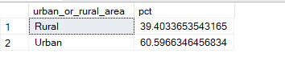

**Current Year**

select urban_or_rural_area , cast (sum(number_of_casualties)as decimal (10,2))*100 /

(select cast (sum(number_of_casualties)as decimal (10,2)) from road_accident where year(accident_date)='2022') as pct

from road_accident

where year(accident_date) = '2022'

group by urban_or_rural_area

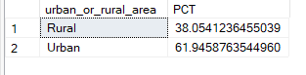

**Casualties By Location Along With Urban & Rural Area**

**Current Year**

select Urban_Or_Rural_Area,sum(number_of_casualties)as Total_Casualties,cast(sum(number_of_casualties) as decimal (10,2))*100 /

(select cast (sum(number_of_casualties)as decimal (10,2)) from road_accident where year(accident_date)='2022') as PCT

from road_accident

where year(accident_date) = '2022'

group by Urban_Or_Rural_Area

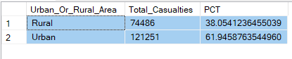

**Previous Year**

select Urban_Or_Rural_Area ,sum(number_of_casualties)as Total_Casualties,cast(sum(number_of_casualties) as decimal (10,2))*100 /

(select cast (sum(number_of_casualties)as decimal (10,2)) from road_accident where year(accident_date)='2021') as PCT

from road_accident

where year(accident_date) = '2021'

group by Urban_Or_Rural_Area

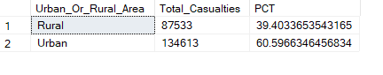

**Casualties By Light Condition**

**Current Year**

select

CASE

when light_conditions in ('daylight')then 'Day'

when light_conditions in ('Darkness - lighting unknown','Darkness - lights lit','Darkness - lights unlit ' , 'Darkness - no lighting') then 'Night'

end as Light_condition,

cast(cast(sum(number_of_casualties) as decimal (10,2)) *100/

(select cast (sum(number_of_casualties) as decimal (10,2)) from road_accident where year (accident_date) = '2022') as decimal(10,2))

as CY_Casualties_PCT

from road_accident

where year(accident_date)='2022'

group by

CASE

when light_conditions in ('daylight')then 'Day'

when light_conditions in ('Darkness - lighting unknown','Darkness - lights lit','Darkness - lights unlit ' , 'Darkness - no lighting') then 'Night'

END

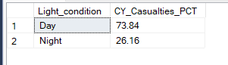

**Previous Year**

select

CASE

when light_conditions in ('daylight')then 'Day'

when light_conditions in ('Darkness - lighting unknown','Darkness - lights lit','Darkness - lights unlit ' , 'Darkness - no lighting') then 'Night'

end as Light_condition,

cast(cast(sum(number_of_casualties) as decimal (10,2)) *100/

(select cast (sum(number_of_casualties) as decimal (10,2)) from road_accident where year (accident_date) = '2022') as decimal(10,2))

as PY_Casualties_PCT

from road_accident

where year(accident_date)='2021'

group by

CASE

when light_conditions in ('daylight')then 'Day'

when light_conditions in ('Darkness - lighting unknown','Darkness - lights lit','Darkness - lights unlit ' , 'Darkness - no lighting') then 'Night'

END

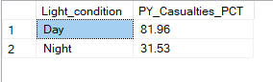

**Top 10 Location By Total Casualties**

select TOP 10 Local_Authority_DISTRICT, sum(number_of_casualties) as TOTAL_CASUALTIES

from road_accident

group by local_authority_DISTRICT

ORDER BY TOTAL_CASUALTIES DESC

